**RESUME**

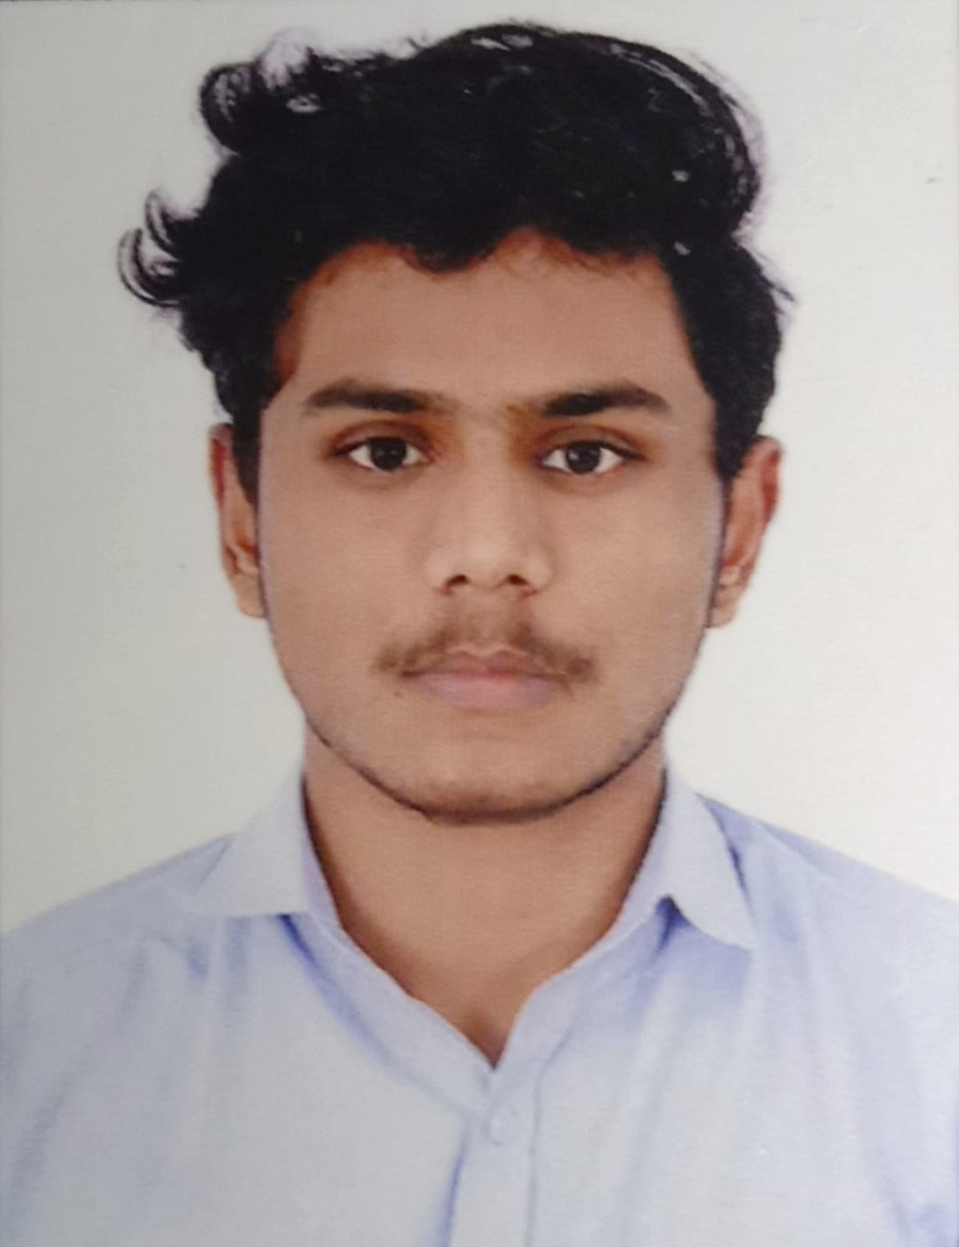

**NAIJIL BENNY**

**Mobile:**

**7025033753**

***E-Mail:***

## **naijilnellikkunnel@gmail.com**



# OBJECTIVE

To secure a challenging position in the field of computer science, where I can utilize my technical skills and knowledge to contribute to the growth of the organization.

**QUALIFICATION**

BSC Computer Science

# Educational Qualification

**Course School/College Board/University Year**

|  |  |  |  |
| --- | --- | --- | --- |
| BSC Computer Science | Don Bosco College  Sulthan Bathery | Calicut University | Result waiting |
| Higher Secondary | TVHS Sulthan Bathery | VHSE | 2020 |
| SSLC | Assumption High School  Sulthan Bathery | Kerala Board of Public Examinations | 2018 |

# CERTIFICATIONS

* Board of vocational SKILL CERTIFICATE
* Trade certificate of Computer Science and Information Technology
* 30days ‘ON THE JOB TRAINING’ at Delta Computer Education, Sulthan Bathery
* Completed course in PYTHON at Reginal Technologies, Calicut
* Workshop on PYTHON,AI,ML,ROBOTICS at Srishti Campus Technopark, Trivandrum
* Workshop on HARDWARE ASSEMBLING and OS INSTALLATION at Don Bosco College, Sulthan Bathery

# Languages known

* English (Read, write and speak)
* Malayalam (Read, write and speak)

# Skills

* Excellent knowledge of subject areas
* Web application development
* Object oriented programming & Databases
* Desktop publishing
* Graphic designing & Visual communication
* Computer hardware maintenance & Networking

# Personal details

Name : Naijil Benny

Date of Birth : 11.03.2003

Age : 20

Sex : Male

Father’s Name : N J Benny

Nationality : Indian

Religion : Christian

Marital Status : Single

Permanent Address : Nellikkunnel (H),

Moolankavu(PO)

Karuvallikkunu

Wayanad, Kerala

673592

Contact No. : +917025033753

# Reference

Prince Joy

Former Head and Professor

Department Of Computer Science and Mathematics

Don Bosco College, Sulthan Bathery

+917902673128

# DECLARATION

I Naijil Benny, hereby declare that the information Contained herein is true and correct to the best of my knowledge and belief.

NAIJIL BENNY